THE SOUTHERN NEWFOUNDLAND
CLUB
PRESIDENT
Mrs. Christine Bodman
CHAIRMAN | SECRETARY | TREASURER
Mrs. Jan Groves | Mrs. Jeni Giambona | Mrs. Loretta Dixon

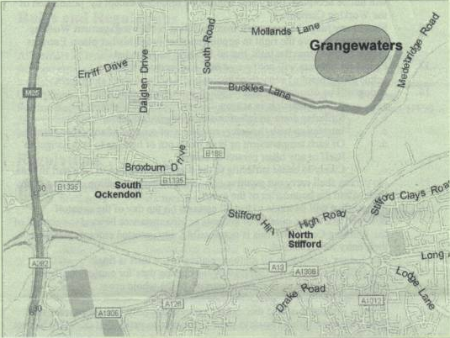
PLEASE NOTE:
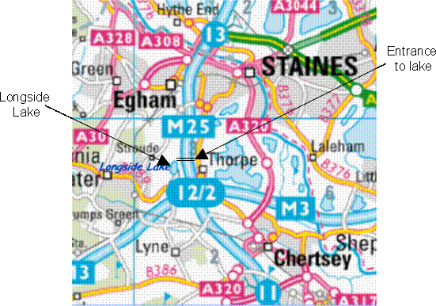
This venue has security gates which will be manned until 11.00am. If you arrive after this time, please ring 07771556397 to have the gates opened for you.
ALSO:
There is a limited number of cabins for overnight accommodation. For further information please contact the Test Manager:
SOUTHERN NEWFOUNDLAND

CLUB
SCHEDULE OF CERTIFIED DRAUGHT TESTS
Hosted by SEWN @
GRANGEWATERS OUTDOOR EDUCATION CENTRE
Buckles Lane, South Ockendon, Essex, RM15 6RS.
Saturday 22nd March 2025 (Beginners, Levels 2 & 4)
Sunday 23rd March 2025 (Levels 1 & 3)
Judges Briefings will commence at 9:30am
Entries and fees to the Test Manager: Ken Richards
20 Fairfield Road
Leigh On Sea
Essex. SS9 5SB
Mobile: 07771556397
e-mail: honestkens@yahoo.co.uk
NB There will be a £5.00 surcharge per dog entered over the weekend, as levied by the park
Late entries may be accepted at the discretion of the Test Manager.

EVENT JUDGES
SATURDAY | Beginners | Alan Godden & Sue Sanders
 | Level 2 | Sue Dobson & Caroline Germain
 | Level 4 | Dave Viney & Kevin Clarke
SUNDAY | Level 1 | Rachel Saunders & Sara Davies
 | Level 3 | Dave Viney & Greg Roffe

TEST RULES / REGULATIONS

All owners of entrants are encouraged to study the requirements of the tests for which they are entered. Full test rules and regulations, including permitted actions, will be available on the day; alternatively you may obtain a copy form the Southern Newfoundland Club website (www.southernnewfoundlandclub.co.uk).

ENTRY REGULATIONS

- Minimum age for entry (on the day of the test) are:

Draught Beginners 12 months
Level 1 18 months
Level 2 24 months
Level 3 24 months
Level 4 30 months (8 years and over not allowed)

- Entry Fees:
SNC Member: £7.00 per dog (subsequent entry: £3.50 per dog)
Non-Members: £9.50 per dog (subsequent entry: £5.00 per dog)
(Subsequent entries only applicable if the Draught Test is held over two days – see regulations)
- No dog may enter tests unless he/she has been successful in the preceding tests at earlier tests organized by the Southern Newfoundland Club, The Newfoundland Club or the Northern Newfoundland Club.
- The tests will commence at the time shown on the front of this schedule and will continue throughout the day (unless specified otherwise on the schedule).
- All entrants must attend the Judges briefing at the appointed times. Entrants who miss the briefing will only be admitted under special circumstances and at the discretion of the Test Manager.
- Owners must be responsible for their dogs at all times. Exercising of dogs within the defined test area is prohibited. All dogs within 25m of the test area must be kept on a lead.
- The Committee/Organizers reserve to itself the right to refuse any entries.
- Every entry form must be completed and accompanied by the correct fees or it will not be accepted. Entry fees will not be refunded except by permission of the committee.
- Should any judge be prevented from fulfilling his/her appointment the committee reserves the right to appoint another judge in his/her place. Entrants may withdraw from the tests, but no entry fee will be refunded.
- The club cannot accept any responsibility for any accident/injury or loss to persons, dogs or other items at the event.
- Confirmation of entry will not be sent. Any person wishing to receive acknowledgement of entry should enclose a S.A.E when entering.
- A dog and its owner/handler will be immediately disqualified and be removed from the event if the dog is:-
- Suffering from an infectious or contagious disease.
- Interfering with the safety or chance of success of any other entrant.
- Of such temperament or so much out of control as to be a danger to itself or any other animal or person.
- Likely to be caused suffering if it continues to take part in these tests.
- A bitch which is in season.
- If the owner/handler carries out any punitive correction or harsh handling at any time within the boundaries of the event.
If a dog is disqualified for any of the above reasons and if the dog has already passed a test at the event then the pass will be rescinded and a report provided by the Test Manager to the SNC committee.
- Every effort will be made to test entrants on the day of the event. If due to circumstances beyond the control of the committee/Organizers this is not possible all entries that have registered on the day will have a full refund.
- Parents are responsible for and must control their children at all times.
- All owners must clear up after their dogs
- The Judges’ decisions in all matters relating to the tests are final. In the event of a disagreement between the two judges the Test Manager, or appointed person, will act as a referee. The Committee will adjudicate on any dispute that remains unresolved on the day or has been notified to the SNC committee within seven days of the event.

SOUTHERN NEWFOUNDLAND CLUB DRAUGHT TEST ENTRY FORM
This form must be completed by one person (or partnership) only. The form must be completed in BLOCK CAPITALS in ink. Use one row only for each dog. Enter details carefully – they will be used when filling out any pass certificates issued and the test records. To enter any tests the dog must be at least 12 months old on the day of the test for Beginners Level, 18 months for level 1, 24 months for level 2 & 3 and 30 months for level 4. Dogs 8 years old & over are not permitted to enter Level 4. No entries will be accepted without the correct entry fees.
Venue: SEWN @ Grangewaters ONE ENTRY FORM PER DOG Saturday 22nd & Sunday 23rd 2025
BREED | Registered Name |  | Call Name | Date of Birth | Sex | Colour | Breeder | Test Entered | Result  P/F
Name of Junior Handler  (if applicable) |  |  |  | Age of Junior Handler (10 yrs -18yrs)
Name
Address

Tel. No:
Owner/Handler name for certificate:
Entry | £.00 | Please tick | Total
SNC Member | £7.00
Non-Members | £9.50
Subsequent Entries  SNC Members | £3.50
Subsequent Entries  Non-Members | £5,00
Please make cheques payable to: South Eastern Working Newfoundlands 20-72-89. 03778894

I/we undertake to abide by the rules and regulations of these tests and declare that the dog entered has not contracted or been knowingly exposed to any infectious disease during the last 6 weeks and is fit and healthy to undertake the tests entered.
SNC Membership Number
Furthermore I/we accept that any breach of the test rules or regulations may result in disqualification

Signature of owner(s)……………………………………………………………………………………………………………………………………………………………………………………………Date………………………………
Entry forms and cheques to be sent to the Test Manager. See schedule for details. If you require an acknowledgement of this entry please enclose a S.A.E.

