THE SOUTHERN NEWFOUNDLAND

CLUB
PRESIDENT
Mrs Del Richards
CHAIRMAN | SECRETARY | TREASURER
Mrs Jan Groves | Mrs Jeni Giambona | Mrs Loretta Dixon

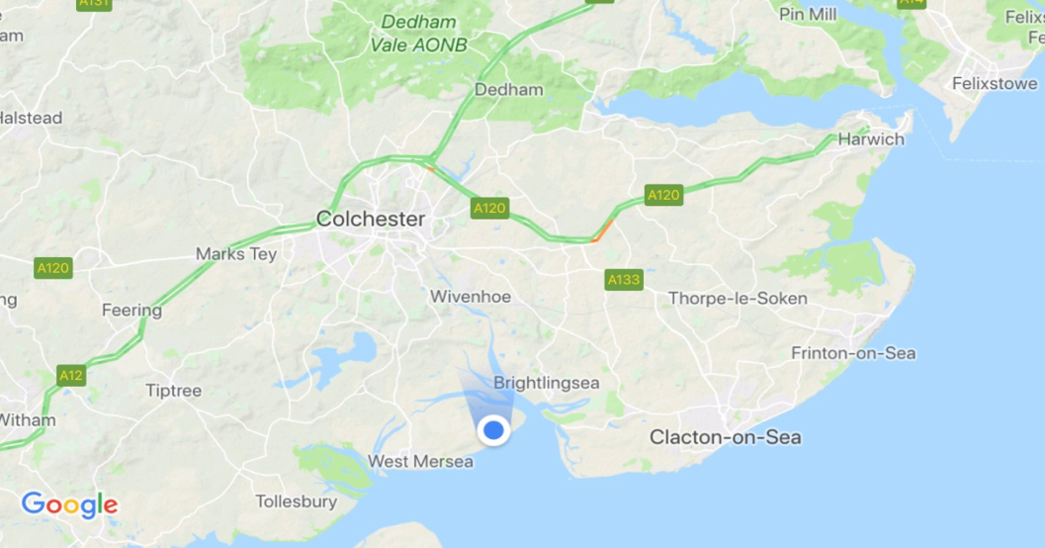
Fen Farm Caravan site is award winning; it has the usual facilities we are used to, plus award winning loos! Please book accomodation directly with the camp site.
Phone 01206 383275
Their website is http://www.fenfarm.co.uk/

Please see separate sheet for directions to venue.
THE SOUTHERN NEWFOUNDLAND

CLUB

SCHEDULE OF CERTIFIED DRAUGHT TESTS
TO BE HELD AT
Fen Farm Caravan Site
Moore Lane
East Mersea
Colchester
Essex CO5 8FE
Saturday 21st March 2026 – NC Tests
Sunday 22th March 2026 (Beginners - Level 3)

Judges Briefings will commence at 9:30am

Entries and Fees to:
TEST MANAGER
Ken Richards
20 Fairfield Road
Leigh On Sea
Essex. SS9 5SB
Mobile: 07771556397
e-mail: honestkens@yahoo.co.uk
ENTRIES TO BE RECEIVED BY Monday 16th March 2026
Late entries may be accepted at the discretion of the Test Manager.
EVENT JUDGES
Draught Tests: SATURDAY NC |  | See N.C. Schedule
Draught Tests:
SUNDAY
 | Beginners | Kevin Clarke & Clive Haylock
 | Level 1 | Greg Roffe & Kevin Clarke
 | Level 2 | Sara Davies & Dave Viney
 | Level 3 | Caroline Germain & Ken Richards

TEST RULES / REGULATIONS
All owners of entrants are encouraged to study the requirements of the tests for which they are entered. Full test rules and regulations, including permitted actions, will be available on the day; alternatively, you may obtain a copy form the Southern Newfoundland Club website (www.southernnewfoundlandclub.co.uk).

ENTRY REGULATIONS

- Minimum age for entry (on the day of the test) are:
Draught Beginners 12 months
Level 1 18 months
Level 2 24 months
Level 3 24 months
Level 4 30 months (8 years & over not allowed)
- Entry Fees:
SNC & NC member: £7.00 per dog (subsequent entry: £3.50 per dog)
Non-Members: £9.50 per dog (subsequent entry: £5.00 per dog)
(Subsequent entries only applicable if the Draught Test is held over two days – see regulations)
Cheques payable to the Welsh Newfoundland Activity Group.
Bank Transfer to The Welsh Newfoundland Activity Group. Sorting Code – 20-84-41
Account Number: 30560227
3 No dog may enter tests unless he/she has been successful in the preceding tests at earlier tests organized by the Southern Newfoundland Club, The Newfoundland Club or the Northern Newfoundland Club.
- The tests will commence at the time shown on the front of this schedule and will continue throughout the day (unless specified otherwise on the schedule).
- All entrants must attend the Judges briefing at the appointed times. Entrants who miss the briefing will only be admitted under special circumstances and at the discretion of the Test Manager.
- Owners must be responsible for their dogs at all times. Exercising of dogs within the defined test area is prohibited. All dogs within 25m of the test area must be kept on a lead.
- The Committee/Organizers reserve to itself the right to refuse any entries.
- Every entry form must be completed and accompanied by the correct fees or it will not be accepted. Entry fees will not be refunded except by permission of the committee.
- Should any judge be prevented from fulfilling his/her appointment the committee reserves the right to appoint another judge in his/her place. Entrants may withdraw from the tests, but no entry fee will be refunded.
- The club cannot accept any responsibility for any accident/injury or loss to persons, dogs or other items at the event.
- Confirmation of entry will not be sent. Any person wishing to receive acknowledgement of entry should enclose a S.A.E when entering.
- A dog and its owner/handler will be immediately disqualified and be removed from the event if the dog is:-
- Suffering from an infectious or contagious disease.
- Interfering with the safety or chance of success of any other entrant.
- Of such temperament or so much out of control as to be a danger to itself or any other animal or person.
- Likely to be caused suffering if it continues to take part in these tests.
- A bitch which is in season.
- If the owner/handler carries out any punitive correction or harsh handling at any time within the boundaries of the event.
If a dog is disqualified for any of the above reasons and if the dog has already passed a test at the event then the pass will be rescinded and a report provided by the Test Manager to the SNC committee.
- Every effort will be made to test entrants on the day of the event. If due to circumstances beyond the control of the committee/Organizers this is not possible all entries that have registered on the day will have a full refund.
- Parents are responsible for and must control their children at all times.
- All owners must clear up after their dogs
- The Judges’ decisions in all matters relating to the tests are final. In the event of a disagreement between the two judges the Test Manager, or appointed person, will act as a referee. The Committee will adjudicate on any dispute that remains unresolved on the day or has been notified to the SNC committee within seven days of the event.

SOUTHERN NEWFOUNDLAND CLUB
DRAUGHT TEST ENTRY FORM
This form must be completed by one person (or partnership) only. The form must be completed in BLOCK CAPITALS in ink. Use one row only for each dog. Enter details carefully – they will be used when filling out any pass certificates issued and the test records. To enter any tests the dog must be at least 12 months old on the day of the test for Beginners Level, 18 months for level 1, 24 months for level 2 & 3 and 30 months for level 4. Dogs over 8 years old are not permitted to enter Level 4. No entries will be accepted without the correct entry fees.
Venue: Mersea ONE ENTRY FORM PER DOG Sunday 22nd March 2026
BREED | Registered Name |  | Call Name | Date of Birth | Sex | Colour | Breeder | Test Entered | Result  P/F
Name of Junior Handler  (if applicable) |  |  |  | Age of Junior Handler (9 yrs -16yrs)
Name
Address

Tel. No:
E-mail:
Owner/Handler name for certificate:
Entry | £.00 | Please tick | Total
SNC & NC Member | £7.00
Non-Members | £9.50
Subsequent Entries  SNC & NC Members | £3.50
Subsequent Entries  Non-Members | £5,00
Bank Transfer to South Eastern Working Newfoundlands, Sorting code: 20-72-89, Account no: 03778894

SNC Membership Number
NC Membership Number

I/we undertake to abide by the rules and regulations of these tests and declare that the dog entered has not contracted or been knowingly exposed to any infectious disease during the last 6 weeks and is fit and healthy to undertake the tests entered.
Furthermore I/we accept that any breach of the test rules or regulations may result in disqualification

Signature of owner(s)…………………………………….……………………………………………………………………… Date……………………………
Entry forms and cheques to be sent to the Test Manager. See schedule for details. If you require an acknowledgement of this entry please enclose a S.A.E
Directions to Fen Farm
If you make your own way to Mersea, as you come on to the Island take the left hand fork, signposted East Mersea - there will be brown information signs for Fen Farm. Follow the road until you go past the “Dog & Pheasant” PH. After the next bend the entrance to the camp site is the first one on the right, Moore Lane. It’s the blue dot on the map. (Do not go as far as the “old” entrance - this takes you to a different site now!)

The road onto the island is liable to flood sometimes when the tide is high. This is not forecast to happen over the weekend of the draught tests!

There are more direct routes but if you want to avoid all of the unclassified roads and country lanes stay on the A12 or A120 to Colchester then take the B1025 to Mersea. However you will need a good map or a SatNav through Colchester as the road signs are intermittent.

If you come off the A12 at Junction 26 (Stanway) and you are towing or in a large van DO NOT TAKE THE ROAD FROM HECKFORD BRIDGE TO LAYER-DE-LA-HAYE, THERE IS A WIDTH LIMIT (6’ 6”). IT IS NOT SUITABLE FOR MOTORHOMES OR CARAVANS. This is the road from the B1022 at the junction near the old Heckford Angel PH (now closed). Go through Colchester instead.

If you are unsure about which way to come please contact the Test Manager for more advice.

